

**Property Analysis BI Developer - On-boarding Task**

**Introduction:**

Welcome! The PA On-boarding Task is designed to familiarize you with technologies that you will be utilising once you join the project team. While the instructions tell you what to do, they do not always necessarily tell you how to do it. This is deliberate as it is important for you to develop an independent drive to solve problems on your own.

You should have a good idea where to start from your 6 weeks of training however if you have any questions we are always here to help. Please utilise QuestionHub to develop a good network of communications with peers and the project team.

**Learning Outcomes:**

* Learn about the relationship between each tables in Keys database.
* Be able to analyse requirements that are not documented;
* Write queries to return the required results.

Note:

* You should put your SQL Query to your own GitHub account. [How to setup GitHub](https://help.github.com/articles/set-up-git/);
* Submit the report as a screenshot.
* Read and follow [Naming Convention for SQL](http://www.industryconnect.io/InternalResources/NamingConvention.pdf);
* Login credential for **Keys** database via SQL Server Management Studio
  + Server: mvpstudio.cdvkl5vm8weq.ap-southeast-2.rds.amazonaws.com
  + username: KeysOnboardUser
  + password: KeysOnboardUser!23

**Task:**

**1. Write queries to return the following:**

1. Display a list of all property names and their property id’s for Owner Id: 1426.
2. Display the current home value for each property in question a).
3. For each property in question a), return the following:
4. Using rental payment amount, rental payment frequency, tenant start date and tenant end date to write a query that returns the sum of all payments from start date to end date.
5. Display the yield.
6. Display all the jobs available in the marketplace (jobs that owners have advertised for service suppliers).
7. Display all property names, current tenants first and last names and rental payments per week/ fortnight/month for the properties in question a).

**2. Use Report Builder or Visual Studio (SSRS) to develop the following report:**

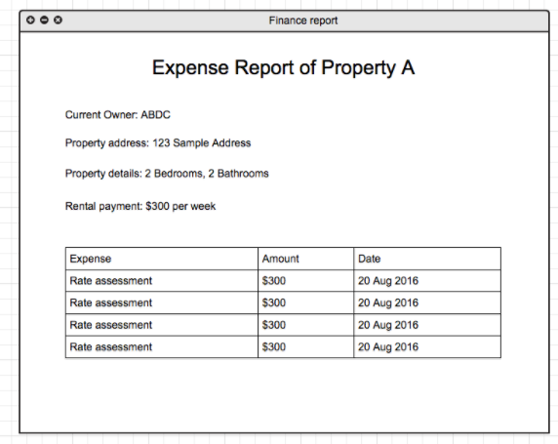

**Submission**

Below are the steps to submit your project for evaluation:

1. Upload your project on google drive
2. Submit your **google drive** on the Internship Portal at the IndustryConnect.IO website.   
   Click on the edit progress icon and enter the urls.
   1. Demo Url : (ignore)
   2. Source Code Url : Google drive url

Note: Your progress has to be at least 50% to submit the urls.

